How to get there

By train – nearest rail station is Denby Dale. 5 mins by taxi/car to hotel. 35-40 mins walk on foot. Taxi booking to reach hotel is recommended.  By car – please read detailed directions to hotel on Bagden Hotel website at: https://www.classiclodges.co.uk/our-hotels/bagden-hall/how-to-find-us/  By air – nearest airports are Leeds Bradford (25 miles from hotel) and Manchester Airport (35 miles from hotel)  Note:- Disabled people/wheelchair users – access is from rear of building | 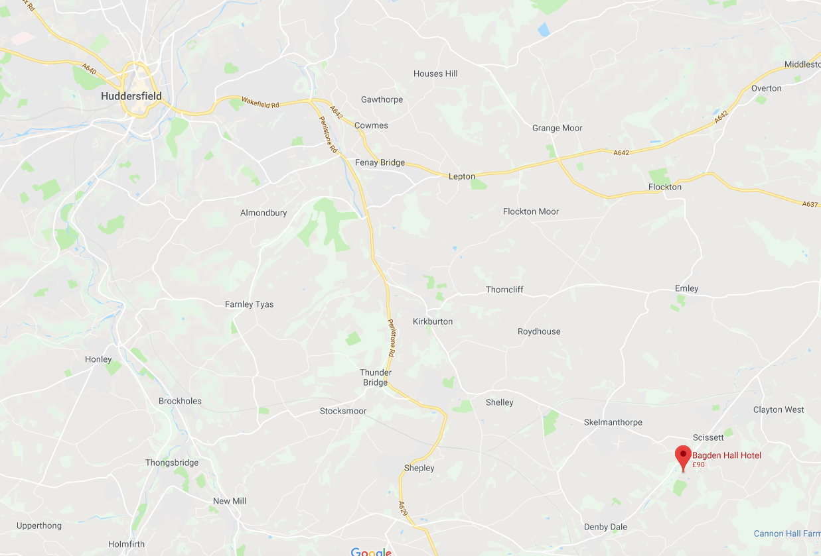

Accommodation Options

There are plenty of places to stay around Scissett area including nearby main towns of Wakefield, Huddersfield and Barnsley.

Hotels

Bagden Hall, Scissett | www.classiclodges.co.uk
Midgley Lodge Motel, Wakefield | http://www.midgleylodgemotel.co.uk
Travelodge, Wakefield (Northbound) | https://www.travelodge.co.uk/hotels/188/Wakefield-Woolley-Edge-M1-Northbound-hotel
The Fairway, Barnsley | http://the-fairway.yorkshire-hotel.com
Cedar Court Hotel, Wakefield | https://www.cedarcourthotels.co.uk/hotels/wakefield

B&B/Inns

The White Heart, Penistone | http://www.thewhiteheart.co.uk
Three Acres Inn & Restaurant, Huddersfield | https://www.3acres.com
The Woodman Inn, Huddersfield | https://www.woodman-inn.com

For enquiries, please contact: -

Jill Jones | Chair of DEX | jilljones@dex.org.uk | 0785 07 44 398
Georgina Brown | Event Organiser | georginabrown4280@yahoo.co.uk | 0775 22 44 237
Ian Randell | Event Co-Organiser | ianrandell@outlook.com | 0752 36 72 094

Deaf Ex-Mainstreamers Group

25th Silver Anniversary Dinner Celebration
“Deaf Together”

12th October 2019

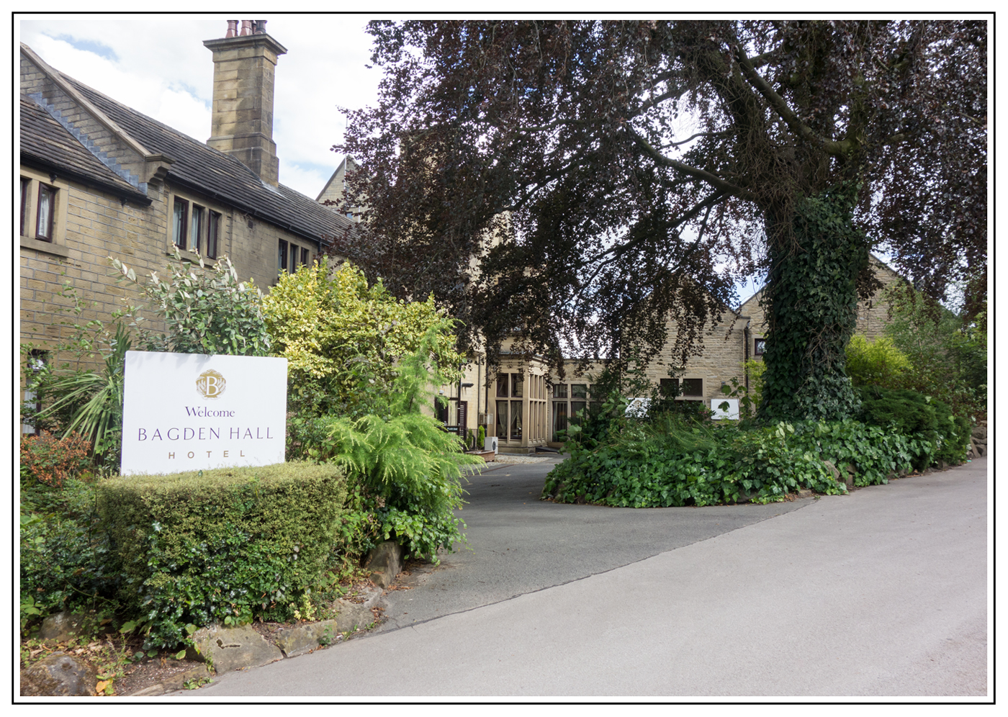

Bagden Hall Hotel
Wakefield Road, Scissett, Denby Dale,
Nr. Huddersfield, West Yorkshire, HD8 8SZ

E: events.bagdenhall@classiclodges.co.uk
W: www.classiclodges.co.uk
T: 01484 865330

