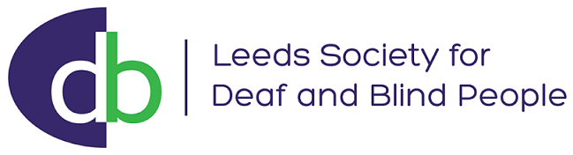

Friendly Contact Service

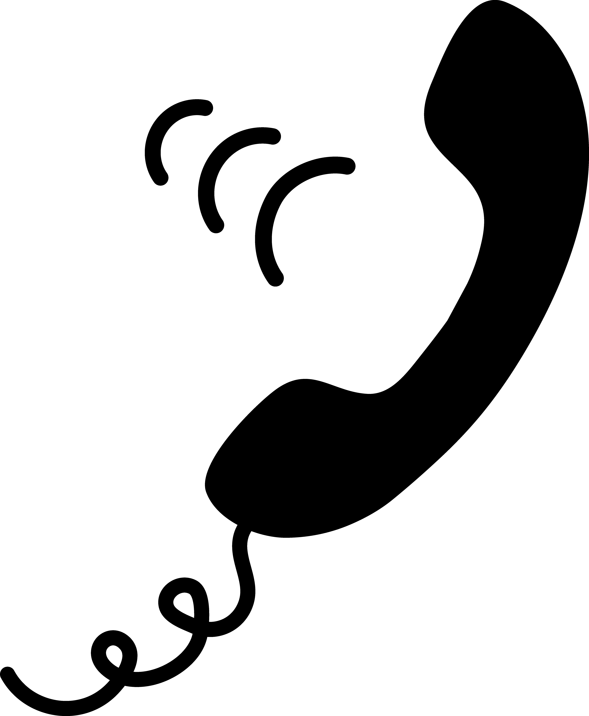

Leeds Society for Deaf and Blind People
Keeping in Touch!

Friendly 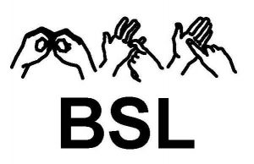 OR 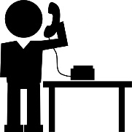 contact
We use Facetime, WhatsApp for BSL Video Calling

Send your number or email we will do the rest!

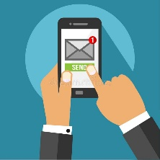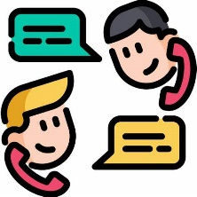

Setting up contact for you or a family member as often as you want.

Contact us:
Text or Call: 07775 444 032 / 07563 382 618

Email: zoe.major@leedssocietyfordeafandblind.org.uk

If you are contacting us on behalf of someone else – please ask permission from them first.

Thank you, we look forward to connecting with you!

